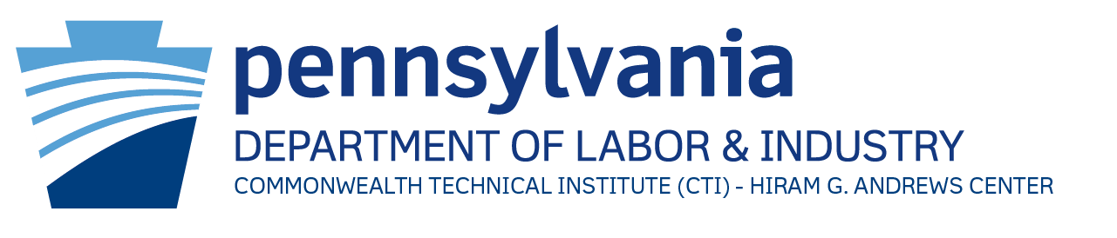



**Eligible if:**

* Age 16-21,
* OVR customer, or;
* Potentially eligible for OVR services

**APS**

* June 25-28
* Maximum of 10 participants

**WORC**

* July 23-26
* Maximum of 12 participants

**Session space is limited, please make referrals by May 1, 2024.**

The participants in each session will reside on-campus in dormitories. Individuals will arrive on Monday to begin programming on Tuesday morning. Sessions will continue daily until 4:00 p.m. with recreational opportunities until 9:00 p.m.

Interested individuals who are already connected with OVR may contact their local OVR office to initiate referrals for programming. Referrals are open to individuals with an open case or who are potentially eligible for services. Other interested individuals and those with questions regarding programming may contact **Stacie Andrews**, **Director of Transition Programs**, at **(814) 254-0557** or [standrews@pa.gov](mailto:standrews@pa.gov).

**Access Planning & Strategies (APS) Academy** – This program provides participants with a foundation of various skills and topics critical for a successful transition from high school to work or post-secondary education. Each participant will gain hands-on experience daily with programs and “apps” on the computer, and other technology to support note-taking, reading, and time-management skills. Individual accommodations will be addressed as needed.

**Working on Readiness for Careers (WORC) Academy** – This program provides participants strength-based opportunities to grow in the domain of work readiness. Participants will engage in interactive, psychoeducational groups and experiential community activities with the goal of being able to: (1) define disability, identify different types of disabilities, and distinguish disability facts from myths, (2) define self-advocacy, practice self-advocacy skills, and name potential reasonable accommodations, and (3) describe the differences between high school and post-secondary education and identify potential education or employment goals. Participants will work toward answering the question of, “How can I use my strengths and abilities to achieve my educational and vocational goals?”

**Access Planning & Strategies (APS) and**

**Working on Readiness for Careers (WORC) Academies**

**with the** **Commonwealth Technical Institute at the**

**Hiram G. Andrews Center**

We are now accepting referrals for **special summer programming** for high school students ages **16-21,** who are Office of Vocational Rehabilitation (OVR) customers with an open case or who are potentially eligible for services and meet admissions criteria for the Commonwealth Technical Institute at the Hiram G. Andrews Center. Please consider this programming for individuals who are interested and may benefit from participation in these summer academies for access planning or work readiness.