Commonwealth Technical Institute  at the  Hiram G. Andrews Center  RSVP by  april 17th to:  Kayla McMullen  (814) 254-0481  kaymcmulle@pa.gov  727 Goucher Street Johnstown, PA 15905  www.dli.pa.gov/CTI-HGAC  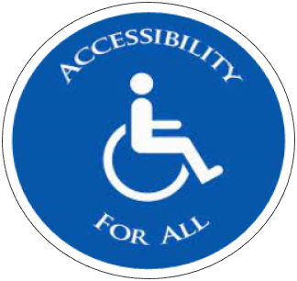 |  | Accessibility, Advocacy  & Awareness Fair  - MAy 1st, 2024 at 11am  Individuals with disabilities, including those using wheelchairs or experiencing vision loss and hearing impairments, may encounter challenges with daily tasks and public activities. They, along with their families, have ongoing concerns about accessibility to businesses and in their communities.  To make the public more aware of these challenges, the Commonwealth Technical Institute at the Hiram G. Andrews Center is sponsoring the Accessibility, Advocacy, and Awareness Fair. This fair will bring awareness to everyday barriers and how individuals can advocate for themselves and others in the community.  Highlighted at the event will be a variety of activities, including accessing public transportation, using wheelchairs or other mobility equipment, and completing problem-solving tasks with adaptive technology and equipment to see the world the way it is for a person with disabilities—barriers and all.
