1. LWDA #  Click or tap here to enter text. | 2. Local Workforce Development Board Name  Click or tap here to enter text. |  | 3. Date of Request  Click or tap here to enter text.
4. Amount of Funding Requested:  Click or tap here to enter text. |  | 5. Employer Match  ☐ 35% Employer Funding Match
6. State/Local Internship Program (SLIP) 2020 Planning Narrative (A second sheet may be attached if needed.) The narrative must include, but is not limited to:
- The economic conditions for youth in the local workforce development area;
- A summary of the SLIP activities or services that will be provided if the funds are awarded;
- The number of total planned participants to be served, and the estimated number of WIOA eligible participants served;
- A description of the targeted participant group(s) to be served (e.g., OSY, high school students, college students, youth with barriers, etc.);
- An indication of the number of participating businesses, and the types of industries represented;
- A description of how the local workforce development area will achieve a 10 percentage point increase in WIOA eligibility among participating youth (if applicable), or sustain a minimum of 40% WIOA eligibility among participating youth;
- A description of how the local workforce development area will achieve 35% employer matching funding contributions, and the number of additional SLIP 2020 placements to be created because of this contribution (if applicable);
- A description regarding how the local board will ensure equal opportunity and diversity among this year’s SLIP participants;
- A description of how the local workforce development area will integrate TIW, BEP, and TANF YDP in their SLIP programming.

Click or tap here to enter text.

General Instructions for the Completion of a Budget Justification Form for SLIP 2020

The budget justification form must include the following information:
- Each line item on the Budget Form must be explained, and the cost provided for each. Each line item on the Budget Form pertains to projected costs.
- The total for each line item on the Budget Information Narrative must match the total for each line item on the Budget Form.
- Administrative Costs must not exceed 10 percent of the requested funding.
- Admin Staff Salaries & Fringe Benefits – List all staff positions by title. State the annual salary of each person, the percentage of each person’s time devoted to the project, the amount of each person’s salary funded by the grant, and the total personnel cost for the period of performance. Provide the overall fringe benefit percentage which reflects the recipient’s organizational fringe, and list the components included, such as health insurance, FICA, retirement, etc. Provide the fringe benefit calculation for each staff position listed under the Personnel line item.

For example:
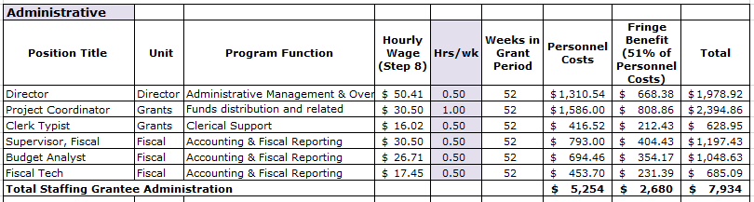
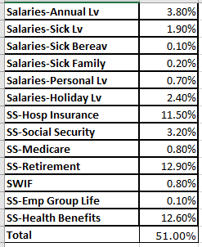

- Admin Operational Expenses – List all anticipated direct operational expenses and corresponding amounts being supported by the grant here.

- Admin Indirect Costs – If charging indirect costs to the grant, this line item must be populated. Include the current approved Negotiated Indirect Cost Rate Agreement, signed by the Federal cognizant agency, as an attachment to narrative.

- Program Staff Salaries & Fringe Benefits – List all staff positions by title. State the annual salary of each person, the percentage of each person’s time devoted to the project, the amount of each person’s salary funded by the grant, and the total personnel cost for the period of performance. Provide the overall fringe benefit percentage which reflects the recipient’s organizational fringe, and list the components included, such as health insurance, FICA, retirement, etc. Provide the fringe benefit calculation for each staff position listed under the Personnel line item.

For example:
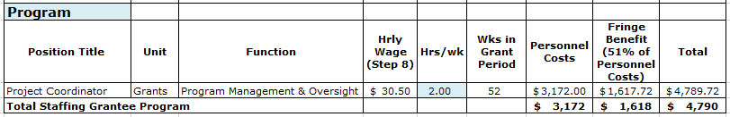

- Program Operational Expenses – List all anticipated direct operational expenses and corresponding amounts being supported by the grant here.

- Other Program Expenses – List the number of anticipated internships, hourly rate and anticipated number of hours. Provide the overall fringe benefit percentage which reflects the recipient’s organizational fringe, and list the components included, such as health insurance, FICA, retirement, etc. Provide the fringe benefit calculation for each internship.

- Supportive Services – List the types of supportive services allowable under your supportive service policy. Include any cap used to calculate the costs for this category.

- Program Indirect Costs – If charging indirect costs to the grant, this line item must be populated. Include the current approved Negotiated Indirect Cost Rate Agreement, signed by the Federal cognizant agency, as an attachment to narrative.

 |  |  |  |  | Award
 |  |  | FUNDING AVAILABLE
 |  |  |  |  | Budget
* | ADMINISTRATION
A1 |  | Admin Staff Salaries & Fringe Benefits
A2 |  | Operational Expenses (e.g. travel, postage, printing, etc.)
A3 |  | Admin Indirect Costs
 | CAREER & SUPPORTIVE SERVICES
B1 |  | Program Staff Salaries & Fringe Benefits
B2 |  | Operational Expenses (e.g. travel, postage, printing, etc.)
B3 |  | Other Program Expenses (Enter internship salary and fringe here.)
B4 |  | Needs Related Payments
B5 |  | Supportive Services
B6 |  | Program Indirect Costs
 | TOTAL BUDGET
 | EMPLOYER MATCH
C1 |  | Projected Employer Matching
 | FINAL PROPOSED BUDGET

Note: Only the categories indicated in yellow should be used for budgets and financial status reporting.

Prior grant recipients achieving an estimated 40% WIOA-eligibility among 2019 participants are required to maintain participation above 40% in 2020. Prior grant recipients whose total participants were less-than 40% WIOA-eligible in 2019 must increase their total percentage of WIOA-eligible participants by 10 percentage points. For example, a grant recipient with 5% WIOA-eligible SLIP participants in 2019 is required to have 15% of their 2020 SLIP participants be WIOA-eligible. Grant recipients are not required to enter prospective participant information into CWDS; however, documentation (i.e. a hardcopy checklist) indicating a reasonable likelihood of WIOA eligibility must be collected for applicants whose participation is being used to count toward the 10% WIOA-eligibility increase requirement. Personally identifiable information collected for this purpose must be stored behind two layers of locked security and accessible only to staff with an essential, SLIP-related need.

