Appendix F: Worker Protection and Investment Certification Form

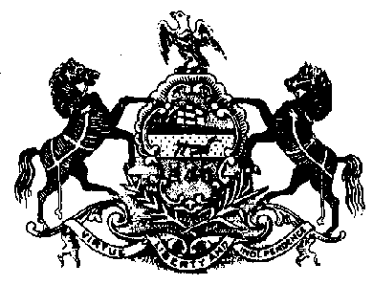
WORKER PROTECTION AND INVESTMENT CERTIFICATION FORM

Pursuant to Executive Order 2021-06, Worker Protection and Investment (October 21, 2021), the Commonwealth is responsible for ensuring that every worker in Pennsylvania has a safe and healthy work environment and the protections afforded them through labor laws. To that end, contractors and grantees of the Commonwealth must certify that they are in compliance with Pennsylvania’s Unemployment Compensation Law, Workers’ Compensation Law, and all applicable Pennsylvania state labor and workforce safety laws including, but not limited to:

Construction Workplace Misclassification Act
Employment of Minors Child Labor Act
Minimum Wage Act
Prevailing Wage Act
Equal Pay Law
Employer to Pay Employment Medical Examination Fee Act
Seasonal Farm Labor Act
Wage Payment and Collection Law
Industrial Homework Law
Construction Industry Employee Verification Act
Act 102: Prohibition on Excessive Overtime in Healthcare
Apprenticeship and Training Act
Inspection of Employment Records Law

Pennsylvania law establishes penalties for providing false certifications, including contract termination; and three-year ineligibility to bid on contracts under 62 Pa. C.S. § 531 (Debarment or suspension).

CERTIFICATION

I, the official named below, certify I am duly authorized to execute this certification on behalf of the contractor/grantee identified below, and certify that the contractor/grantee identified below is compliant with applicable Pennsylvania state labor and workplace safety laws, including, but not limited to, those listed in Paragraph A, above. I understand that I must report any change in the contractor/grantee’s compliance status to the Purchasing Agency immediately. I further confirm and understand that this Certification is subject to the provisions and penalties of 18 Pa. C.S. § 4904 (Unsworn falsification to authorities).

Signature Date
Name (Printed)
Title of Certifying Official (Printed)
Contractor/Grantee Name (Printed)

BOP-2201
Published: 02/07/2022

