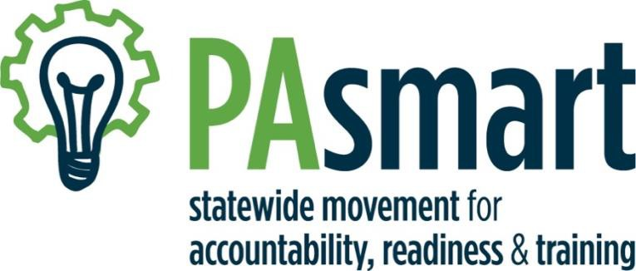

Growing Registered Apprenticeships and
Pre-Apprenticeships in Pennsylvania Grant Program

August 2021

Table of Contents
Introduction 3
What is PAsmart? 3
PAsmart: Growing Registered Apprenticeships and Pre-Apprenticeships 3
Apprenticeship and Training Office, PA Department of Labor and Industry 4
PAsmart PY 20/21 Funded Grant Opportunity Specifics 5
Grant Opportunity 1: Building, Supporting and Expanding Registered Apprenticeship and Pre-Apprenticeship Programs 5
Grant Opportunity 2: Supporting Registered Apprenticeship and Pre-Apprenticeship through Ambassador Networks 10
PAsmart Grant Information 14
Eligibility 14
Fiscal Agent 14
Application Process 14
Proposed Grant Timeline and Award Period 14
Program Reporting and Evaluation 14
Grant Award Administration 14
Application Submission Information 15
Completed Application Components 15
Vendor Registration 17
Submission Instructions 17
Reference Links for Additional Information: 18
Key Dates 19
Appendix A: What is Registered Apprenticeship and Pre-Apprenticeship? 20
Appendix B: Program Expenses 21
Appendix C: Evaluation Criteria 23
Appendix D: Project Summary Cover Page 26
Appendix E: PAsmart Apprenticeship Application Form 27
Appendix F: PAsmart Apprenticeship Grant Budget Form 29
Appendix G: Budget Justification 30
Appendix H: FSR Cost Categories 32
Appendix I: Goals/Outcomes Table 35
Appendix J: Timeline 36

Introduction

What is PAsmart?
Governor Wolf’s PA Statewide Movement for Accountability, Readiness and Training (PAsmart) framework is designed to better align education, workforce and economic development initiatives and funding.

PAsmart is based on four goals:
- Strategically investing resources in initiatives to support economic growth and education and training opportunities;
- Achieving successful outcomes for Pennsylvania students, workers, businesses, and communities;
- Improving coordination and alignment of education and workforce development programs, services and funding; and
- Transforming inter-agency, cross-sector collaboration around education, workforce and economic development at state, regional and local levels.

The PAsmart initiative was designed as strategic, competitive and cross-sector investment focused on meeting the education and workforce development needs of students, workers, employers, and communities across Pennsylvania, including those disconnected from education and workforce opportunities.

PAsmart grants support the following PAsmart Principles and Funding Priorities:

- Data-driven Innovation
- Cross-sector Partnership
- Cross-sector Alignment
- Stakeholder Engagement
- Equity, Diversity and Inclusion
- Capacity Building
- Leveraging Existing Resources
- Performance Outcomes

For more information on the PAsmart Framework: Principles and Funding Priorities, please see: https://www.governor.pa.gov/wp-content/uploads/2018/11/20181102-PAsmart-Framework.pdf.¹

PAsmart: Growing Registered Apprenticeships and Pre-Apprenticeships

The 2020/2021 Governor’s PAsmart Growing Registered Apprenticeships and Pre-Apprenticeships initiative was created in partnership with the Pennsylvania Department of Labor and Industry’s Apprenticeship and Training Office to provide up to $12.5 million in two competitive grant opportunities to align, expand and diversify the apprenticeship model to include non-traditional occupations, non-traditional program models and non- traditional populations. This grant program seeks to expand Registered Apprenticeships in new industries and occupations and aims to advance individuals along career pathways with secondary and post-secondary schools. Additionally, this initiative is intended to reach underrepresented populations, including women, minorities, individuals with disabilities, veterans, socio-economic disadvantaged individuals, individuals who speak English as a second language, individuals who were previously incarcerated, or individuals experiencing multiple barriers to employment.
Applications will be evaluated by a diverse inter-agency team, and successful applicants will be selected based on the Evaluation Criteria described herein, including alignment with the PAsmart Framework: Principles and Funding Priorities. Specifically, these funds will support apprenticeship through the following opportunities:

- $11.5 million is available to build, support and expand Registered Apprenticeship and Pre-Apprenticeship Programs with specific focus on diverse talent pipelines and underserved populations, non-traditional occupations, alignment with secondary and/or post-secondary educational institutions, and expedited growth through multi-county or statewide initiatives.

- $1 million is available to support Registered Apprenticeships and Pre-Apprenticeship through ambassador networks across the Commonwealth.

Apprenticeship and Training Office, PA Department of Labor and Industry
The Apprenticeship and Training Office (ATO) within the PA Department of Labor & Industry is responsible for guiding and promoting the expansion of apprenticeship programs across the state. As a State Apprenticeship Agency (SAA), the ATO is responsible for overseeing the development and approval of programs, agreements and policy that support apprenticeship and is working to embed a focus on apprenticeships within the State’s workforce system and PA CareerLink® offices. While the Commonwealth of Pennsylvania accepts and supports the Federal Standards of Apprenticeship and works closely with the federal office, the ATO has developed PA’s own set of apprenticeship standards that are specific to the Commonwealth. The ATO supports sponsors with the resources they need to implement high quality apprenticeship programs, including through the PAsmart grant program.

Since the ATO’s creation in 2016, it has assisted in creating 352 Registered Apprenticeship Programs. In total, the team supports 892 individual program sponsors and 1,504 Registered Apprenticeship Programs across the Commonwealth, as well as 17,797 active registered apprentices (as of June 2021).

This PAsmart grant initiative supports the ATO’s strategic goals, including:

- Developing a strong talent pipeline of individuals that are well-positioned to succeed in Registered Apprenticeship and Pre-Apprenticeship as a career pathway opportunity;
- Promoting diversity and inclusion in Registered Apprenticeship and Pre-Apprenticeship, both in the people and industries they serve, including women, minorities, individuals with disabilities, veterans, socio-economic disadvantaged individuals, individuals who speak English as a second language and individuals who were previously incarcerated, or individuals experiencing multiple barriers to employment;
- Scaling up the volume of new and existing Registered Apprenticeship and Pre-Apprenticeship Programs and occupations through the Group Sponsorship model to support small- and medium- sized companies with the administration and planning associated with Registered Apprenticeship and Pre-Apprenticeship;
- Developing regional Apprenticeship Networks to support consortiums of employers, intermediaries, training providers, and other partners all working to develop a community of practice and strong system of Registered Apprenticeship and Pre-Apprenticeship;
- Supporting efficient and effective use of workforce development resources by promoting larger cohorts to train multiple Registered Apprentices and Pre-Apprentices at the same time; and
- Identifying and sharing best practices in the Commonwealth and across the nation to share with stakeholders.

PAsmart PY 20/21 Funded Grant Opportunity Specifics

Grant Opportunity 1: Building, Supporting and Expanding Registered Apprenticeship and Pre-Apprenticeship Programs

Available Funding
A total of $11.5 million in competitive funding is available with a focus on the following:

- Diverse Talent Pipelines and Underserved Populations: Build new or expand current Registered Apprenticeship Programs with a concentration on recruiting from diverse talent pipelines and serving populations traditionally underserved in Registered Apprenticeship. Programs should have a focus on diversity, equity, and inclusion, as well as career pathways to opportunities that pay a living wage;
and/or
- Non-Traditional Occupations: Support the expansion of Registered Apprenticeships into non-traditional occupations and/or industries/sectors through building new or expanding current Registered Apprenticeship Programs;
and/or
- Career Pathways: Expand apprenticeship and/or pre-apprenticeship initiatives in close alignment with secondary and/or post-secondary educational institutions concentrating on Career Pathway system growth;
and/or
- Expedited Growth and Wider Reach: Support the expansion of apprenticeship and/or pre-apprenticeship programs that have a statewide or multi-county reach allowing for expedited growth of quality programming across the Commonwealth.

Building on the first two rounds of PAsmart funding, this $11.5 million grant opportunity will award competitive grants up to $400,000 per application for apprenticeship and/or pre-apprenticeship programs that have a single-county or localized reach. Competitive grants up to $650,000 will be awarded per application for apprenticeship and/or pre-apprenticeship programs that have a statewide or multi-county reach (three or more counties).

Grantees will coordinate their activity with the ATO’s mission and vision, and PAsmart Principles and Funding Priorities. Funding must supplement, not supplant existing Registered Apprenticeship and Pre-Apprenticeship initiatives, and have a built-in sustainability plan.

Needs and Purposes
The ATO is focused on addressing and fulfilling the following needs and purposes through this grant opportunity:

Diverse Talent Pipelines and Underserved Populations
Apprenticeships have a track record of success in advancing the careers of workers. Specifically, apprenticeship programs are a great opportunity to address education and skill needs when it comes to individuals with barriers to employment and often those in underserved communities. Apprenticeship allows us to reach a pool of potential workers that may not have been able to engage in career development due to various barriers and/or needing to earn a consistent income. Apprentices are full time employees and earn a wage while they are learning the skills needed to be successful in that occupation, industry and at that jobsite.

Still, apprenticeships are severely behind in serving under-represented populations and supporting diversity, equity and inclusion (DEI) within their programs. For example, women accounted for only 7.3 percent of the people who completed Registered Apprenticeships in 2017, and their median hourly wage was just $11.49, compared with $27.25 for men who completed apprenticeships that year, according to a 2018 study by the Center for American Progress. Similarly, African Americans who completed Registered Apprenticeships in 2017 were earning a median hourly wage of $14.35, compared with $26.14 for their white counterparts. In 2019, 88% of new apprentices coming into federally registered programs were male, and 56% were white².

As recommended by Jobs for the Future², “Taking steps to open up apprenticeship to more women, people of color, youth, and members of other demographic groups that have historically been underrepresented in work-based learning programs can expand access to defined career pathways and jobs that pay good wages. Redesigning apprenticeship systems so that they explicitly focus on diversity, equity and inclusion is the only way to deliver the promise of apprenticeship to all Americans. Improving diversity in apprenticeship—and, in turn, the entire workforce—will also benefit employers, not just workers.”

Non-Traditional Occupations
Apprenticeships have been utilized to meet the needs of America’s skilled workforce for more than 75 years but many still think of occupations mainly associated with apprenticeship as those in the building trades like electrician and plumber. Now more than ever we should look to expand apprenticeship beyond the traditional trades and occupations as we look for innovative solutions to the current workforce needs. As we continue through what has proven to be a trying year, apprenticeship is a key to the long-term economic recovery for businesses and job seekers across all sectors. Apprenticeship is a way for businesses to build and retain the skilled workforce they need and allow job seekers to earn while they learn and grow in their career.

Career Pathways
Fundamentally, a Career Pathways System is about the coordination of people and resources to help individuals on a continuous path to family sustaining employment and growth in a career. Within education, this coordination includes aligning our state’s K–12 and postsecondary education systems, as well as the career and technical education services provided within and across program providers, closely mirroring the apprenticeship structure, model and desired results. Recognizing these parallels in methodology, the ATO’s intent is to directly align and integrate the Career Pathways System within the overall apprenticeship structure.

Expedited Growth and Wider Reach
The Commonwealth continues to support the growth of group sponsored and/or Registered Apprenticeship and Pre-Apprenticeship Programs that serve multiple counties as they allow for expedited growth of quality programming across the Commonwealth. In a group sponsorship model, a sponsor organization brings employers together and helps them jointly prepare and register an apprenticeship to train people to develop skills that they all need. Group sponsor organizations are often industry associations, unions, community-based organizations, training providers, and other organizations that serve as the lead, convener and administrator of the program. Since group sponsors take on the administrative work involved in setting up a Registered Apprenticeship program, group sponsored programs can be a great way to address the workforce needs of various sectors and industries and can be a significant help for small businesses that may not have been able to keep up with the administration of an apprenticeship program otherwise. By pulling together a group of similar employers, they can efficiently provide sponsor services to multiple businesses while developing a workforce made up of people whose skills are in demand across a region or the state.

Through this PAsmart grant opportunity, the ATO’s goal is to encourage:
- Development or expansion of a diverse pipeline of underserved Registered Apprentices from non-traditional populations, including women, people of color, individuals with disabilities, veterans, socio-economic disadvantaged individuals, individuals who speak English as a second language, individuals who were previously incarcerated, or individuals experiencing multiple barriers to employment;

- Development or expansion of Registered Apprenticeships into non-traditional occupations and/or industries/sectors;
    - These non-traditional apprenticeships would be targeting occupations in sectors that are found outside of manufacturing and the building trades;
      - These sectors include, but are not necessarily limited to, healthcare, information technology, telecommunications, hospitality, food service, and transportation. The term “non-traditional apprenticeships” is not to be confused with terms like “non-traditional students” or “non-traditional models”. When those terms are being addressed, they should be properly mentioned as such.
      - In the context of occupation, traditional apprenticeships include, but are not limited to (source Burning Glass³), Boilermakers, Brickmasons and Blockmasons, Carpenters, Cement Masons and Concrete Finishers, Construction Laborers, Drywall and Ceiling Tile Installers, Electrical Power-Line Installers and Repairers Installation, Electricians, Elevator Installers and Repairers, Floor Layers, Except Carpet, Wood and Hard Tiles, Glaziers Construction and Extraction Occupations, Heating, Air Conditioning, and Refrigeration, Mechanics and Installers Installation, Heavy and Tractor- Trailer Truck Drivers, Industrial Machinery Mechanics Installation, Machinists, Millwrights Installation, Operating Engineers and Other Construction, Equipment Operators, Painters, Plumbers, Pipefitters, and Steamfitters, Reinforcing Iron and Rebar Workers, Roofers, Sheet Metal Workers, Structural Iron and Steel Workers, Structural Metal Fabricators and Fitters, Telecommunications Equipment Installers, Repairers, and Except Line Installers.
- Development of group sponsored programs with a far reach across the Commonwealth or other multiple county reaching programs;
    - Group sponsored programs may allow for small business and other organizations that could not engage with apprenticeship as an individual program to utilize a quality program structure. This will assist with program consistency and use of industry standards while still allowing for up to 20% customization by employer.
  - Growth of pre-apprenticeship programs that are replicated in multiple counties and/or regions;
- Development or expansion of pre-apprenticeship and Registered Apprenticeship Programs that closely align and partner with secondary and post-secondary schools;
- Development or expansion of Registered Apprenticeship and Pre-Apprenticeship Programs that focus on career pathways to opportunities that pay a living wage.

Priority Consideration
Priority consideration will be given to applicants that demonstrate alignment with the PAsmart Principles and Funding Priorities. Proposals must support:

- Data-driven Innovation: Proposals identify a clear problem, challenge or opportunity supported by relevant data and information and include an innovative strategy to increase opportunity for Pennsylvania students, workers, employers, and communities.

- Cross-sector Partnership: Proposals demonstrate an effort to develop strong, high-quality cross-sector partnerships committed to working collaboratively to implement the proposal. Applicants are encouraged to have multiple partners across sectors (e.g. education partner, including secondary and post-secondary educational institutions, workforce development, business, economic development, and community partners) that demonstrate their commitment through letters of support.

- Cross-sector Alignment: Proposals align with existing local, regional and state education, workforce and economic development initiatives.

- Stakeholder Engagement: Proposals engage partners, customers and stakeholders, including the target population, in the development of the proposal and its implementation.

- Equity, Diversity and Inclusion: Proposals demonstrate a commitment to serve and increase access for historically under-represented and under-served students, workers, businesses, and communities. Applicants are encouraged to identify and address barriers to education and employment.

  - Capacity Building: Proposals build the applicant’s or partners’ organizational capacity to better implement the proposal and support students, workers, businesses, and communities.

- Leveraging Existing Resources: Proposals demonstrate PAsmart resources will leverage and supplement, not supplant, existing public and private resources (e.g. other federal or state grants and philanthropic contributions, cash, in-kind, etc.). Proposals demonstrate efficient and effective use of resources.

- Performance Outcomes: Proposals include measurable performance outcomes and a strategy to conduct an evidence-based evaluation of the program’s outcomes and overall effectiveness.

Priority consideration will also be given to initiatives that focus on the following, which are specific to this grant opportunity:
- New, previously unfunded initiatives;
- Registered Apprenticeship Programs;
- Serving populations traditionally underserved in apprenticeships especially those with multiple barriers to employment such as the Re-Entry or returning citizen population and those with criminal backgrounds;
      - Expansion of apprenticeship to nontraditional occupations and industry/sectors.

Project Outcomes Per Grantee
- Develop or expand Individual Registered Apprenticeship Programs that serve at least 8 apprentices during the grant period;
and/or
- Develop or expand Registered Apprenticeship Programs that utilize a group model that serves at least 3 employers and 25 apprentices during the grant period;
and/or
- Develop or expand Registered Pre-Apprenticeship Programs that serve at least 20 pre-apprentices in programs with a career pathway concentration and close alignment with secondary and/or post-secondary educational institutions during the grant period;
and/or
- Develop or expand Registered Apprenticeship Programs that utilize a group model to reach multiple counties that serves at least 6 employers/locations and at least 40 apprentices during the grant period;
- Must demonstrate a reach across 3 or more counties
and/or
- Develop or expand Registered Pre-Apprenticeship Programs that are replicated across multiple counties, align with at least 3 Registered Apprenticeship Programs, and serve at least 40 pre-apprentices during the grant period.
  - Must demonstrate a reach across 3 or more counties
Organizations who are interested in these grant opportunities, but who cannot meet the capacity requirements, should contact the ATO for information on existing programs in their area who may be willing to partner.

Program Expenses
- Reference Appendix B for a complete list of eligible program expenses.

Evaluation Criteria
Applications will be reviewed by an inter-agency team and evaluated based on the criteria in Appendix C.

Grant Opportunity 2: Supporting Registered Apprenticeship and Pre-Apprenticeship through Ambassador Networks

Available Funding
Up to $1 million in competitive funding is available for intermediaries to support the statewide Apprenticeship Ambassador Network through creating new or supporting existing local and/or regional apprenticeship ambassador networks. This $1 million grant opportunity will award competitive grants up to $200,000 per application. Grant awards will support new or existing local or regional apprenticeship ambassador networks across the Commonwealth concentrating on growing apprenticeship in multiples sectors, not just one industry, as well as building a network of people trained on growing programming and apprenticeship ecosystems long term well after the expiration of this grant. Grants will be awarded based on the availability of funds. Grantees will coordinate their activity with the ATO’s mission and vision and PAsmart Principles and Funding Priorities.

Needs and Purposes
As outlined by Jobs for the Future⁴, quality-driven and effective intermediaries provide critical services to support a Registered Apprenticeships system by:
- Connecting businesses and industry groups to organized labor partners and other regional partners;
- Aggregating the needs of small employers within industry sectors;
- Conducting industry engagement and outreach;
- Supporting the progress of Registered Apprentices and Pre-Apprentices;
- Building relationships with training providers;
- Sponsoring Registered Apprenticeships and Pre-Apprenticeships;
- Researching, documenting, and sharing promising practices.

Through this PAsmart grant opportunity, the ATO’s goal is to encourage:
- Development of local and/or regional apprenticeship ambassador networks which are designed to support the expansion of Registered Apprenticeship and Pre-Apprenticeship and extend the reach of the ATO by providing technical assistance to regional consortiums of apprenticeship and pre-apprenticeship stakeholders, including employers, intermediaries, training providers, and other partners.

Roles and responsibilities of local and/or regional apprenticeship ambassador networks:
- Create, grow or enhance a set network of people trained on building programming and apprenticeship ecosystems and provide a sustainability plan for after the expiration of this grant
- Partner with PA CareerLink® or One Stop Centers with a concentration on training or supporting Title One staff or other workforce development professionals who act as Ambassadors and grow this work
- Concentrate on serving areas within one or multiple existing regions which include: South Western, North Western, North Central, South Central, North Eastern, and South-Eastern
- Support and partner with previously existing Ambassador Networks across the Commonwealth in the following regions: South Western, North Western, North Central, South Central, North Eastern, and South-Eastern
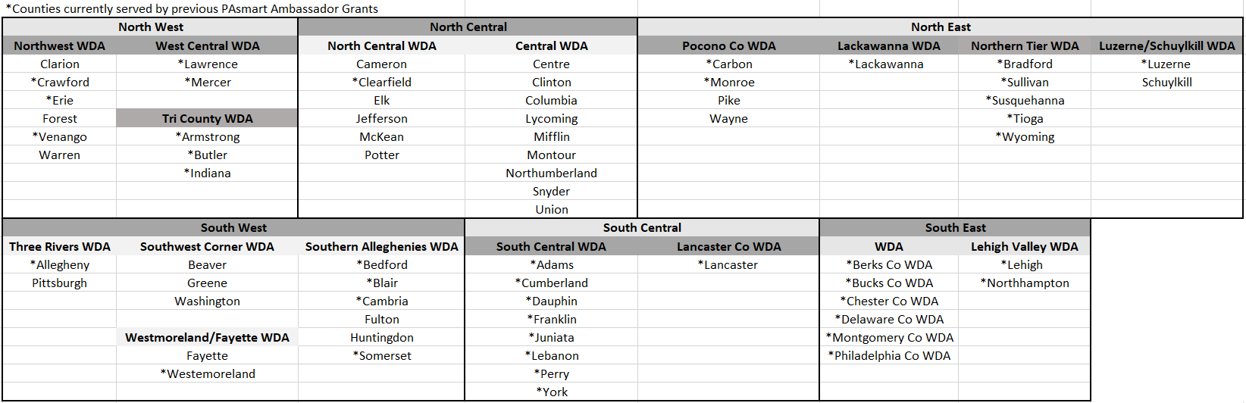

- Provide consortiums, employers, intermediaries, training providers, and other partners with uniform technical assistance to expand Registered Apprenticeship and Pre-Apprenticeship Programs and build their capacity (demonstrate the coverage of multiple counties and extended reach if possible)
- Convene employers and training providers to facilitate a dialog around training and workforce development needs (must provide proof of relationship across workforce system in desired area of coverage)
- Develop curriculum and align on-the-job training with related technical instruction to assist employers and training providers to develop an effective and efficient training delivery model
- Develop program delivery tools to attract and retain Registered Apprentices and Pre-Apprentices and facilitate program growth
- Develop outreach and engagement strategies to connect with employers, training providers and supporting partners with the Apprenticeship Ambassador Network
- Develop in detail the project timeline by creating a roadmap to include implementation steps necessary to achieve outcomes, milestones, plans for long term sustainability, and ability to scale and replicate
- Conduct national and statewide research, identify and share best practices across the Commonwealth, including with the ATO and among local and/or regional apprenticeship ambassador networks
- Train, coach and provide continuous support to a network of people who will be charged with building apprenticeship programs and apprenticeship ecosystems within a certain geographical area, etc.
- Assist in building, registering, maintaining, and enhancing Registered Apprenticeship Programs which includes the following:
  - Assistance in Ecosystem building and Program Design through planning, meeting facilitation, etc.
  - Working in partnership with the ATO to take potential programs through the registration process and prepare to present to the Apprenticeship and Training Council
  - Assist newly approved programs in launching and maintaining their program
  - Assist programs build and develop capacity and multiple entry points for apprentices
  - Assist and act as support to local workforce professionals as they connect jobseekers to apprenticeship
- Support various initiatives/projects that will drive the creation of new programs and expand apprenticeship into non-traditional occupations and serve underrepresented populations
- Provide resources and presentations and support designed to educate on apprenticeship and advocate for it as a premier solution to workforce needs
- Provide access to information related to federal and state funding opportunities available to support apprenticeship

Priority Consideration
Priority consideration will be given to applicants that demonstrate alignment with the PAsmart Principles and Funding Priorities. Proposals must support:

- Data-driven Innovation: Proposals identify a clear problem, challenge or opportunity supported by relevant data and information, and include an innovative strategy to increase opportunity for Pennsylvania students, workers, employers, and communities.

- Cross-sector Partnership: Proposals demonstrate an effort to develop strong, high-quality cross-sector partnerships committed to working collaboratively to implement the proposal. Applicants are encouraged to have multiple partners across sectors (e.g. education partner, including secondary and post-secondary educational institutions, workforce development, business, economic development, and community partners) that demonstrate their commitment through letters of support.

- Cross-sector Alignment: Proposals align with existing local, regional and state education, workforce, and economic development initiatives.

- Stakeholder Engagement: Proposals engage partners, customers and stakeholders, including the target population, in the development of the proposal and its implementation.

- Equity, Diversity and Inclusion: Proposals demonstrate a commitment to serve and increase access for historically under-represented and under-served students, workers, businesses, and communities. Applicants are encouraged to identify and address barriers to education and employment.

  - Capacity Building: Proposals build the applicant’s or partners’ organizational capacity to better implement the proposal and support students, workers, businesses, and communities.

- Leveraging Existing Resources: Proposals demonstrate PAsmart resources will leverage and supplement, not supplant, existing public and private resources (e.g. other federal or state grants and philanthropic contributions, cash, in-kind, etc.). Proposals demonstrate efficient and effective use of resources.

- Performance Outcomes: Proposals include measurable performance outcomes and a strategy to conduct an evidence-based evaluation of the program’s outcomes and overall effectiveness.

Priority consideration will also be given to initiatives that focus on the following, which are specific to this grant opportunity:
- Programs that address ambassador networks covering largely uncovered counties: Reference chart above for starred (*) counties currently served;
- Serving populations traditionally underserved in apprenticeships especially those with multiple barriers to employment such as the Re-Entry or returning citizen population and those with criminal backgrounds;
- Expansion of apprenticeship to nontraditional occupations and industry/sectors.

Project Outcomes Per Grantee
- Direct or indirect involvement in building, maintaining or enhancing 3 Registered Apprenticeship Programs and 2 Registered Pre-Apprenticeship Programs in at least 3 different sectors/industries;
and
- Demonstrate that a network of individuals is trained to be able to effectively support apprenticeship/pre-apprenticeship programming and ecosystem building and growth;
and
- Specifically, demonstrate training or support of Title One staff or other workforce development professionals who act as ambassadors and grow this work;
and
- Demonstrate service within one or multiple regions and partnering with already existing apprenticeship ambassador networks in the following established areas/regions: South Western, North Western, South Central, North Central, North Eastern, and South-Eastern;
and
- Demonstrate that you are partnering and coordinating with PA CareerLink® or One Stop Centers and other strategic partners such as secondary and post-secondary institutions.

Organizations who are interested in these grant opportunities, but who cannot meet the capacity requirements, should contact the ATO for information on existing programs in their area who may be willing to partner.

Program Expenses
- Reference Appendix B for a complete list of eligible program expenses.

Evaluation Criteria
Applications will be reviewed by an inter-agency team and evaluated based on the criteria in Appendix C.

PAsmart Grant Information

Eligibility
Eligible applicants include organizations that serve as sponsors or intermediaries of Registered Apprenticeship and/or Pre-Apprenticeship, including businesses, community-based organizations, economic development organizations, industry associations, labor organizations, local education agencies, local workforce development boards, nonprofit organizations, post-secondary institutions, public libraries, and STEM ecosystems. Please note that this is a reimbursement grant. Funding is only provided to grantees after expenses have been incurred.

Fiscal Agent
Any eligible applicant may serve as fiscal agent for this grant.

Application Process
All PAsmart funding Notice of Grant Availability and related materials, including the PAsmart Framework, proposal requirements, and forms, FAQs, and webinar information are available on the PAsmart website: https://www.dli.pa.gov/Businesses/Workforce-Development/grants/Pages/default.aspx⁵.

For more information and resources about the PAsmart initiative, visit www.pasmart.gov⁶.

Proposed Grant Timeline and Award Period
PAsmart funding is anticipated to be used for grant-related activities between January 1, 2022 and June 30, 2024. Please note that the PAsmart grant funding stream is subject to a yearly waiver process and must receive approval from the State to allow for the continuation of the grant and funding. Specifically, this process begins in the second quarter of the calendar year and finishes in the third quarter. Grantees are asked not to spend funding beginning July 1st following the first year of their grant and each consecutive year, until approval is received. Any funds expended during that time may not be reimbursed if the waiver is not approved. Waivers are not guaranteed. Grantees must be aware that the grant may be terminated at any point should the funding not be extended/available/waivered.

Program Reporting and Evaluation
Grantees will be required to submit program and fiscal reports during and upon conclusion of the funded project. All required forms will be supplied by the Commonwealth and will be outlined in the award package. All close-out final reports are to be submitted no later than August 30, 2024 or within 60 days of full award expenditure (whichever occurs first). In addition to report submissions, awardees are required to participate in routine calls with Commonwealth staff, unless otherwise determined, to identify grant progress, share best practices and receive technical support. Additional information will be provided upon award selection.

Grant Award Administration
Awardees are required to enter into a workforce grant agreement with the Pennsylvania Department of Labor & Industry (L&I) unless the awardee is a local workforce development board. L&I reserves the right to seek repayment of funds if it is determined that funds were not utilized for the original stated and approved purpose.

L&I also reserves the right to award grants ensuring program diversity and alignment with other public funding and/or initiatives. L&I reserves the right to request modifications to applications based on questions raised during the review process. L&I shall notify all applicants whose applications are not accepted for funding under this NGA.
The Commonwealth may enter into discussions with a selected applicant for any reason deemed necessary, including but not limited to: (1) the budget is not appropriate or reasonable; (2) only a portion of the application is selected for award; (3) the Commonwealth needs additional or clarifying information; (4) special terms and conditions are required.

Failure to satisfactorily resolve the issues identified by the Commonwealth within a specific period determined by the Commonwealth may preclude award to the applicant.

The Commonwealth reserves the right, without qualification, to reject any or all applications received in response to this announcement and to select any application, in whole or in part, as a basis for negotiation and/or award. The Commonwealth reserves the right to award grants on a conditional basis if there are concerns surrounding one or more sections of the application(s). In the instance that a conditional award is made, the applicant is responsible to take immediate and appropriate action to remedy the area of concern in accordance with Department guidance.

The contracting officer is the only individual who can make awards or commit the Commonwealth to the expenditure of public funds. A commitment by anyone other than the contracting officer, either explicit or implied, is invalid.

Application Submission Information
Applications must be complete, including all mandatory components outlined below, and submitted by
5:00 PM on October 13, 2021.

All applications must be no more than 12 pages (one-page max for Project Summary Cover Page, 1-page max for Application Form, and 10 pages max for Project Narrative). All applications must be single spaced on 8.5” by 11” paper, with 1” margins using 11-point Calibri font. Budget documents and letters of support do not count toward the 12 pages.

All submitted application documents must be in Adobe Portable Document Format (PDF) or Microsoft Office. Incomplete applications or applications that do not meet these specifications will not be evaluated or scored. If an application is more than 12 pages, evaluators will only review the first 12 pages.

Completed Application Components
Completed applications must including the following components:

- Project Summary Cover Page (saved as a single file called “Project Summary Cover Page” and one- page max) with the following information:
  - Name of applicant;
  - Name of fiscal agent;
  - Project title;
  - Grant opportunity for which applicant is applying;
  - Project partners;
  - Project service area (e.g., counties to be served, and House and Senate legislative districts);
  - Project summary;
  - Project point of contact and contact information.

The Project Summary Cover Page is available in Appendix D.

- Apprenticeship PAsmart Application Form (saved as a single file called “Application Form” one-page max.)

The Apprenticeship PAsmart Application Form is available in Appendix E.

- Project Narrative (saved as a single file called “Project Narrative” and 10 pages max) with the following information:
  - Details answering all of the evaluation criteria, and sub criteria, outlined herein, including:
    - Project Design and Management Plan (25 points);
    - Stakeholder Engagement (15 points);
    - Impact and Sustainability (15 points);
    - Budget Form and Budget Justification (20 points); and
    - Other Evaluation Criteria, including Priority Considerations (25 points).

- Letters of Support (saved as a single file called “Letters of Support”):
Each application must have at least three letters of support. Each application must have at least one letter from an education, workforce development, or business/economic development partner.

- Budget Form (saved as a single file called “Budget Form”):
Applicants must submit a detailed budget that includes expenditures by line item. The budget will be evaluated based on the Evaluation Criteria above, and in terms of cost reasonableness and the relationship to proposed activities. Budgets must be for the time-period January 1, 2022, and June 30, 2024. The budget will also become the financial basis for any grant award, including making cost reimbursement payments over the course of the project. L&I reserves the right to unilaterally modify application budgets, prior to, and/or after grant award.

The Budget Form is available in Appendix F and includes examples.

Use Appendix H, FSR Cost Category, as an additional resource when completing the budget form to assist with titling and defining each available cost category.

- Budget Justification (saved as a single file called “Budget Justification”):
Applicants must justify each expenditure by line item, including the costs proposed in each cost category and any other information to support the budget.

The Budget Justification instructions are available in Appendix G.

Additional resources are available on L&I’s grants website:
http://www.dli.pa.gov/Businesses/Workforce-Development/grants⁷.

- Goals/Outcomes Table:
Describe in detail the desired outcomes of the proposed initiatives and how the outcomes will be measured. Include measurable goals, outcomes, services, performance indicator, evaluation method, target numbers to be served or results, and a timeline to meet the goal or outcome.

Use Appendix I, Goals/Outcomes Table, to clearly illustrate each category.

- Timeline:
Describe in detail the project timeline by creating a roadmap to include implementation steps necessary to achieve outcomes, cohort start and finish dates, milestones, plans for long term sustainability, and ability to scale and replicate. Timeline should be broken down by each quarter within the grant period.

Use Appendix J, Timeline, as a guide to creating a roadmap of the project.

Vendor Registration
All applicants and fiscal agents must be registered with the Commonwealth as a vendor. Applicants and fiscal agents that are not current vendors are strongly encouraged to begin this process immediately following the application submission by registering their organization with the Vendor Data Management Unit (VDMU) at http://www.vendorregistration.state.pa.us⁸ or by calling 717-346-2676 or 1-877-435-7363. Applicants who are not registered with VDMU at the time of award may have their award rescinded.

Submission Instructions
An electronic copy of the application and all components MUST be emailed to the RA-LIATO-GRANTS@PA.GOV resource account by 5:00 PM on October 13, 2021 with the email subject: “PAsmart 2020/2021 NGA Application: Grant Opportunity Number: Title of Grant Opportunity, Name of Applying Organization.”

Reference Links for Additional Information:

¹https://www.governor.pa.gov/wp-content/uploads/2018/11/20181102-PAsmart-Framework.pdf.

²https://www.jff.org/what-we-do/impact-stories/center-for-apprenticeship-and-work-based- learning/diversity- equity-and-inclusion-apprenticeship-wbl/

³https://www.burning-glass.com/apprentices-u-s/
⁴https://www.jff.org/points-of-view/seven-ways-intermediaries-help-develop-apprenticeship-programs/

⁵https://www.dli.pa.gov/Businesses/Workforce-Development/grants/Pages/default.aspx

⁶PAsmart A statewide movement for accountability, readiness, and training

⁷http://www.dli.pa.gov/Businesses/Workforce-Development/grants

⁸http://www.vendorregistration.state.pa.us

⁹https://www.pacareerlink.pa.gov/jponline/Common/Apprenticeships

Date/Time | Event | Details
8/12/2021 | Release of PAsmart Notice of Grant Availability (NGA) | $12.5 million in PAsmart grants:  - $11.5 million to build, support and expand Registered Apprenticeship and Pre-Apprenticeship Programs with focus on:  - Diversified Talent Pipelines and Underserved Populations  - Non-Traditional Occupations  - Career Pathways  - Expedited Growth and Wider Reach  - $1 million to support Registered Apprenticeship and Pre-Apprenticeship through ambassador networks across the Commonwealth.
8/17/2021  3:00 PM | Bidders Webinar – For Grant Opportunity #1 | JOIN MICROSOFT TEAMS MEETING  Microsoft Teams meeting  Join on your computer or mobile app  Click here to join the meeting  Or call in (audio only)  +1 267-332-8737, 343977368# United States, Philadelphia  Phone Conference ID: 343 977 368#  Find a local number
8/18/2021  1:00 PM | Bidders Webinar – For Grant Opportunity #2 | JOIN MICROSOFT TEAMS MEETING  Microsoft Teams meeting  Join on your computer or mobile app  Click here to join the meeting  Or call in (audio only)  +1 267-332-8737, 85687852# United States, Philadelphia  Phone Conference ID: 856 878 52#  Find a local number
10/13/2021  5:00 PM | PAsmart Grant Application  Deadline | All PY20/21 PAsmart Grant Opportunity application and all components MUST be emailed to the RA-LIATO-GRANTS@PA.GOV resource account with the email subject: “PAsmart 2020/2021 NGA Application: Grant Opportunity Number: Title of Grant Opportunity, Name of Applying Organization.”

Key Dates

Appendix A: What is Registered Apprenticeship and Pre-Apprenticeship?

While many students are looking for traditional higher education, there are other education and training options that can lead to family-sustaining wages and meaningful careers. Many of these jobs are middle skills occupations that require a high school diploma but not a college degree. Registered Apprenticeship offers a pathway to a high-paying career and the middle class by acquiring these skills. Apprenticeships are innovative training programs that allow employers to develop and prepare their future workforce, while providing individuals with a learn-while-you-earn approach to career development. Registered Apprenticeships are a combination of on-the-job training and job-related instruction and result in receiving a nationally recognized credential.

Pre-Apprenticeship programs lay the foundation for future apprentices by preparing qualified candidates with academic knowledge and skills training tailored to specific jobs and industries while contributing to the development of a diverse and skilled workforce. Each pre-apprenticeship program establishes a connection to an existing apprenticeship program and delivers both hands-on and instructional-based learning through a variety of unique program designs and approaches. Apprentices and pre-apprentices learn both the theory and application of a highly-skilled occupation.

Benefits of Registered Apprenticeship include:

- Learning valuable employability and technical job skills
- Earning a salary during training
- Obtaining real world work experience
- No student/trainee debt
- Gaining National Industry Certification and other credentials
- Connecting directly with an employer

Registered Apprenticeship and Pre-Apprenticeship offers employers the ability to customize and tailor the training and program to their specific workforce development needs. Workers benefit from high-quality education and training, and access to a career pathway that pays a family-sustaining wage in industries experiencing growth. Workers also earn a good wage while they learn, earn a credential of value, and complete their training debt-free. These Apprenticeship and Pre-Apprenticeship Programs are officially registered with the Pennsylvania Department of Labor and Industry (L&I) which ensures quality and adherence to the model.
Registered Apprenticeships⁹ and Pre-Apprenticeships offer a unique opportunity for collaboration between employers, training providers, workers, and other partners.

Appendix B: Program Expenses

Apprenticeship programs funded by this grant must be registered in the Commonwealth. Non- Registered Apprenticeships Programs will have until May 2022 to finalize their registration or show progress towards the finalization of the registration. The ATO will define “making progress” towards registration on a case-by-case basis. Grantees who do not make adequate progress toward their registration may have funds de-obligated. Additional information will be provided to each awarded applicant.

Due to the limited amount of funding, only items and activities directly related to eligible programs and activities covered in this request for application will be funded by the PAsmart grant. All budgets will be reviewed to evaluate appropriateness and connection to proposed grant activities and goals.

- Eligible expenses must be outlined in detail in budget form (Appendix F) and budget justification (Appendix G) and may include items such as: *See Appendix H for more detailed information on FSR Cost Categories. Reimbursement of the classroom component of an apprenticeship program resulting in stackable and often-transferrable credentials.
- The cost of tuition for registered apprentices and registered pre-apprentices.
- Outreach and marketing materials and campaigns to attract apprentices and pre-apprentices or in the case of the Ambassador Network Opportunity educate on and advocate for Registered Apprenticeship.
- Operational expenses as it relates directly to the participant such as travel, cellphone, rent, video conferencing services, postage, printing/copying, and other similar expenses.
- Supplies for participants and supplies to remain with program provider for program use. No one supply item to exceed more than $5,000. i.e. one laptop cannot exceed $5,000 for one individual.
- Equipment for apprenticeship training or Ambassador Network related or activities.
- Program staff and instructor salaries and fringe benefits.
- Supportive Services which by definition are services that enable an individual to participate in training and includes but not necessarily limited to assistance with linkages to community services, transportation, child care and dependent care, housing, educational testing, reasonable accommodations for individuals with disabilities, legal aid services, referrals to health care, assistance with work attire and work related tools, assistance with books, fees, school supplies and payments and fees for employment and training related applications, tests and certifications.
- Incentives for Pre-Apprenticeship ONLY – Incentives are permitted for recognition and achievement directly tied to training activities and work experiences. Incentives are Non-Cash Assets (Assets) referring to any item that holds immediate cash value, including but not limited to, gift cards, signed or certified checks, bus passes, gas cards, and bearer bonds. This may also include items purchased that hold no immediate cash value, that were acquired with the intent to issue them as incentives.
- Contractor Services Grantees, sub-grantees, and contractors are to adhere to standards of conduct and be vigilant to prevent conflicts of interest. Grantees must neither solicit nor accept gratuities, favors, or anything of monetary value from contractors, potential contractors, or parties to sub-agreements. Such standards of conduct will provide for penalties, sanctions, or other disciplinary actions for violations by officers, employees, agents, or by contractors of their agents. The grantee’s procurement system must ensure that contractors perform in accordance with terms, conditions, and specifications of their contracts or purchase orders. Services are subject to financial and programmatic monitoring, careful analysis of performance, and the review of documentation and reports. See Appendix G, Budget Justification, for more information on Procurement Methods.

This is not an exhaustive list of eligible expenses that may be funded. Applicants are encouraged to create customized proposals to meet their regional needs; however, only items and activities directly related to eligible programs and activities covered in this request for application will be funded by the PAsmart Grant.

All budgets will be reviewed to evaluate appropriateness and connection to proposed grant activities and goals. Indirect costs, building construction, and procuring lobbying services are expressly disallowable.

Appendix C: Evaluation Criteria

Project Design and Management Plan (25 points)
  - Describe the need for the creation of a new initiative or the expansion of an existing initiative; (5 points)
  - Identify the type of program this initiative will address (include the characteristics of the individuals(s) or employers(s) to be served under this initiative), including the number of Registered Apprentices and Pre-Apprentices served. Demonstrate the coverage of multiple counties and extended reach if possible, show reach on map; (5 points)
  - Describe how the proposed initiative aligns with the Pennsylvania’s WIOA Combined State Plan; (2 points)
  - Describe how the proposed initiative aligns with the local workforce development board’s Plan or Regional Plan, including how the initiative will accept referrals from or provide referrals to the local workforce system; (3 points)
  - Describe in detail the desired outcomes of the proposed initiatives and how the outcomes will be measured. Include goals, outcomes, services, and numbers to be served. In addition, use Appendix I – Goals/Outcomes Table to clearly illustrate outcomes; (5 points)
  - Describe in detail the project timeline by creating a roadmap to include implementation steps necessary to achieve outcomes, cohort start and finish dates, milestones, plans for long term sustainability, and ability to scale and replicate. Use Appendix J – Timeline to clearly illustrate. (5 points)

Stakeholder Engagement (15 points)
- Identify key partners and additional partners; (3 points)
- Outline the roles and responsibilities of each partner; (3 points)
- Identify ability of the applicant to implement grant responsibilities of identified partners; (3 points)
- Identify applicant’s prior track record related to recent workforce grants, if applicable; and
(3 points)
- Identify the ability of the key personnel on the grant to foster collaboration and implement programs, including identifying each person by name and how they will support the initiative. (3 points)

Impact and Sustainability (15 points)
- Describe how proposed activities will promote the PAsmart initiative; (3 points)
- Identify any certifications and/or credentials to be obtained by participants; (3 points)
- Identify the impact of the programs and partnerships developed; (3 points)
- Describe how the partnership has the capacity to and will track and report on program data, such as performance metrics on recruitment, participation, accomplishments, impact, and related activities of the partnership; and (3 points)
- Describe how the partnership will sustain this work in the future, including after the grant period ends. (3 points)

Budget Form and Budget Justification (20 points)
- Provide a complete budget broken out by line item. As described in Appendix G and Using Appendix F - Budget Form as a template; and (10 Points)
- Provide a detailed budget justification, including a detailed breakout of quantity, cost and narrative to support each line item of the budget reflective of the scope of the project and number of participants to be served. If staff will be funded by the grant, provide a description of the duties and responsibilities of each staff person to be funded. Any salary and fringe being charged, must show the proportion amount being charged and reason for this amount (i.e. you cannot just charge 8 hours a day for every trainer/mentor). (10 Points)

Other Evaluation Criteria (25 points)

Priority Consideration – PAsmart Principles and Funding Priorities (15 points)
Priority consideration will be given to applicants that demonstrate alignment with the PAsmart Principles and Funding Priorities. Proposals must support:

- Data-driven Innovation: Proposals identify a clear problem, challenge or opportunity supported by relevant data and information, and include an innovative strategy to increase opportunity for Pennsylvania students, workers, employers, and communities.

- Cross-sector Partnership: Proposals demonstrate an effort to develop strong, high-quality cross-sector partnerships committed to working collaboratively to implement the proposal. Applicants are encouraged to have multiple partners across sectors (e.g. education partner, including secondary and post-secondary educational institutions, workforce development, business, economic development, and community partners) that demonstrate their commitment through letters of support.

- Cross-sector Alignment: Proposals align with existing local, regional and state education, workforce and economic development initiatives.

- Stakeholder Engagement: Proposals engage partners, customers and stakeholders, including the target population, in the development of the proposal and its implementation.

- Equity, Diversity and Inclusion: Proposals demonstrate a commitment to serve and increase access for historically under-represented and under-served students, workers, businesses, and communities. Applicants are encouraged to identify and address barriers to education and employment.

  - Capacity Building: Proposals build the applicant’s or partners’ organizational capacity to better implement the proposal and support students, workers, businesses, and communities.

- Leveraging Existing Resources: Proposals demonstrate PAsmart resources will leverage and supplement, not supplant, existing public and private resources (e.g. other federal or state grants and philanthropic contributions, cash, in-kind, etc.). Proposals demonstrate efficient and effective use of resources.

- Performance Outcomes: Proposals include measurable performance outcomes and a strategy to conduct an evidence-based evaluation of the program’s outcomes and overall effectiveness.

Priority Consideration – Opportunity-Specific (10 points)

Grant Opportunity 1
Priority consideration will be given to initiatives that focus on:
- New, previously unfunded initiatives;
- Registered Apprenticeship Programs;
- Serving populations traditionally underserved in apprenticeships especially those with multiple barriers to employment such as the Re-Entry or returning citizen population and those with criminal backgrounds;
      - Expansion of apprenticeship to nontraditional occupations and industry/sectors.
Grant Opportunity 2
Priority consideration will be given to initiatives that focus on:
- Programs that address ambassador networks covering largely uncovered counties: Reference chart on page 11 for starred (*) counties currently served;
- Serving populations traditionally underserved in apprenticeships especially those with multiple barriers to employment such as the Re-Entry or returning citizen population and those with criminal backgrounds;
- Expansion of apprenticeship to nontraditional occupations and industry/sectors.

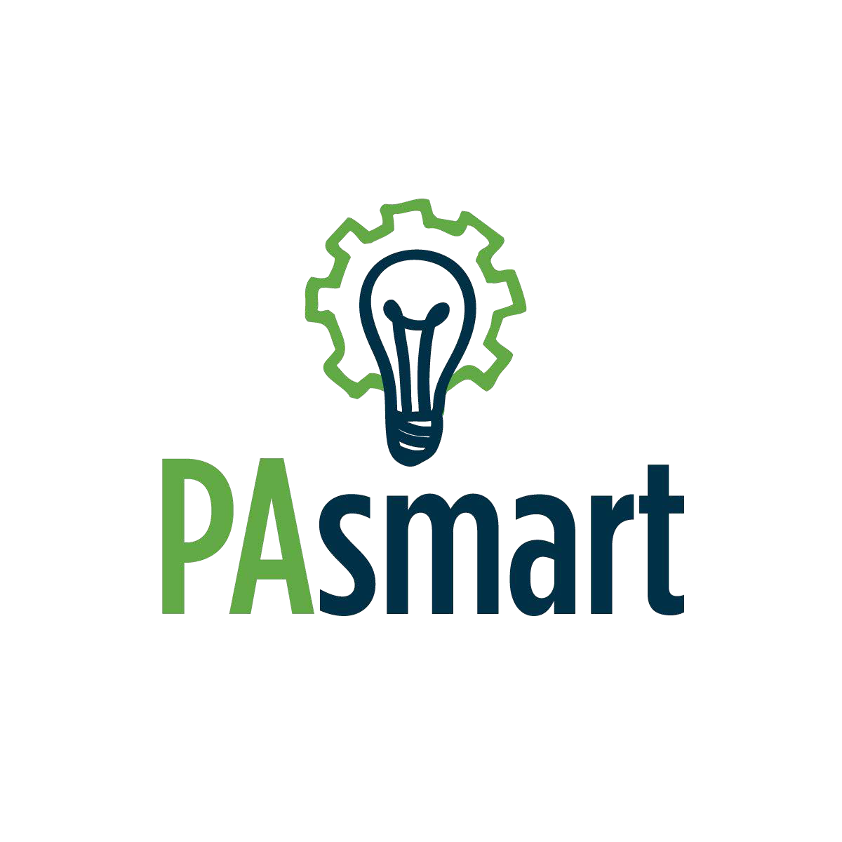
Appendix D: Project Summary Cover Page

Growing Registered Apprenticeships and
Pre-Apprenticeships in Pennsylvania Grant Program

Project Summary Cover Page

Name of Applicant:
Name of Fiscal Agent:

Project Title:

Please Check Here if Applying for Both Grant Opportunities: ☐
*Please note that separate grant applications/packages are required per opportunity.
Select Applicable Grant Opportunity:
☐ Opportunity 1: Building, Supporting and Expanding Registered Apprenticeship and Pre-Apprenticeship Programs

Select Focus Area(s) (check all that apply – refer to pages 5-6 for additional information):
☐ Diverse Talent Pipelines and Underserved Populations ☐ Non-Traditional Occupations ☐ Career Pathways ☐ Expedited Growth and Wider Reach

Identify Project Outcome(s) to be Measured During the Grant Period (check all that apply – refer to page 8 for additional information):
☐ Develop or expand Individual Registered Apprenticeship Programs that serve at least 8 apprentices
☐ Develop or expand Registered Apprenticeship Programs that utilize a group model that serves at least 3 employers and 25 apprentices
☐ Develop or expand Registered Pre-Apprenticeship Programs that serve at least 20 pre-apprentices in programs with a career pathway concentration and close alignment with secondary and/or post-secondary educational institutions

☐ Develop or expand Registered Apprenticeship Programs that utilize a group model to reach multiple (3 or more) counties that serves at least 6 employers/locations and at least 40 apprentices
☐ Develop or expand Registered Pre-Apprenticeship Programs that are replicated across multiple (3 or more) counties, align with at least 3 Registered Apprenticeship Programs, and serve at least 40 pre-apprentices

☐ Opportunity 2: Supporting Registered Apprenticeship and Pre-Apprenticeship Through Ambassador Networks
Project Partners:

Project Service Area (e.g., counties to be served and House and Senate legislative districts):
Project Point of Contact (including Phone Number and Email Address):

Project Summary:

Appendix E: PAsmart Apprenticeship Application Form

Application Form

Type of Submission: |  | Choose an Item |  |  | Type of Project: | Choose an item. |  | Applicant Type:
Local Workforce Development Board:
Grant / Project Title:
Targeted Industry Cluster: |  |  |  |  |  |  | Sub-Cluster:
Counties served by this grant:
- Adams ☐ Clarion ☐ Huntingdon ☐ Montgomery ☐ Venango
- Allegheny ☐ Clearfield ☐ Indiana ☐ Montour ☐ Warren
- Armstrong ☐ Clinton ☐ Jefferson ☐ Northampton ☐ Washington
- Beaver ☐ Columbia ☐ Juniata ☐ Northumberland ☐ Wayne
- Bedford ☐ Crawford ☐ Lackawanna ☐ Perry ☐ Westmoreland
- Berks ☐ Cumberland ☐ Lancaster ☐ Philadelphia ☐ Wyoming
- Blair ☐ Dauphin ☐ Lawrence ☐ Pike ☐ York
- Bradford ☐ Delaware ☐ Lebanon ☐ Potter ☐ Statewide
- Bucks ☐ Elk ☐ Lehigh ☐ Schuylkill
- Butler ☐ Erie ☐ Luzerne ☐ Snyder
- Cambria ☐ Fayette ☐ Lycoming ☐ Somerset
- Cameron ☐ Forest ☐ McKean ☐ Sullivan
- Carbon ☐ Franklin ☐ Mercer ☐ Susquehanna
- Centre ☐ Fulton ☐ Mifflin ☐ Tioga
- Chester ☐ Greene ☐ Monroe ☐ Union
Local Workforce Development Areas (LWDA) affected by this grant:
- Allegheny ☐ Lackawanna ☐ Pittsburgh ☐ West Central
- Berks ☐ Lancaster ☐ Southern Alleghenies ☐ Southwest Corner
- Bucks ☐ Lehigh Valley ☐ Tri-County ☐ Northwest
- Chester ☐ Luzerne-Schuylkill ☐ North Central ☐ Central
- Delaware ☐ Montgomery ☐ Northern Tier ☐ South Central
- Westmoreland-Fayette ☐ Philadelphia ☐ Poconos ☐ Statewide
Is your business a Pennsylvania Qualified Small Business as described in 4 Pa. Code 2.32? |  |  |  |  |  |  |  |  | Choose an item.
Applicant Information
Name Address 1
Address 2
City PA ZIP Code
Name and contact information of primary person to be contacted on matters involving this application
First Name Last Name Phone
Title Email
Funding proposal request ($): |  |  |  |  | Labor & Industry: $ Matching Funds: $
Authorized representative printed name: |  |  |  |  | Name

Authorized representative signature/date:

Application Form
Application Instructions
Labor & Industry (L&I) Workforce Development Grant

- Type of Submission: Indicate whether this is a new request for funds for a new project or if this is a continuation of a project that was previously funded.
- Type of Project: Indicate whether this grant is for training or services.

- Applicant: Enter Applicant type.

- Local Workforce Development Board (LWDB): Enter the name of the LWDB with whom this project will be affiliated.
- Grant/Project Title: Enter the name of the project.

- Target Industry Cluster/Sub Cluster: Enter the name of the Industry Cluster and, if applicable, the sub-cluster.
- Counties Served – Include all counties that will be served by the grant.

- LWDAs affected – List all LWDAs involved in the grant.

- Small Business – Select whether your business is a Pennsylvania Qualified Small Business.

- Applicant Information: Enter the applicant’s name and address.

- Contact Information: Enter contact information.

- Funding Proposal Requests: Enter the amount requested for the project and include the amount of matching funds (if applicable).

- Authorized Representative: Enter the name of the authorized representative. Sign and date the form.

Appendix F: PAsmart Apprenticeship Grant Budget Form

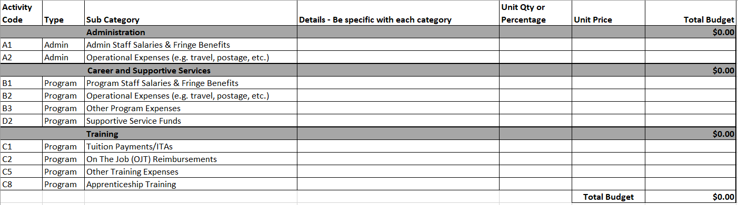

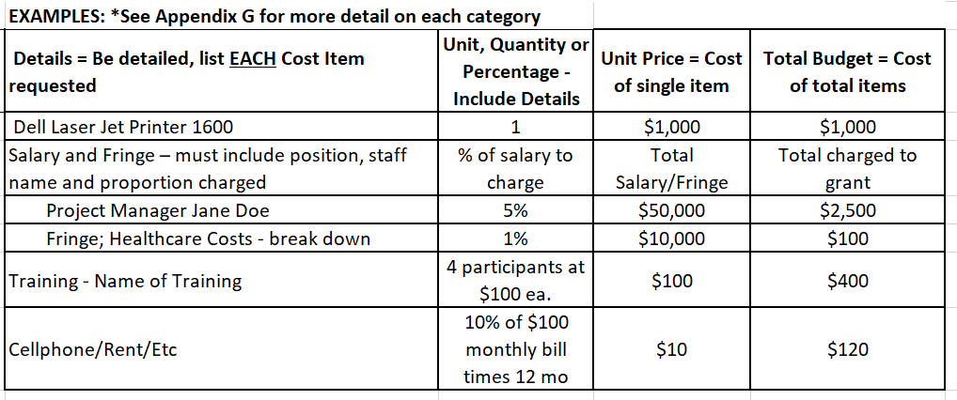

Appendix G: Budget Justification

General Instructions for the Completion of a Budget Justification
The budget justification must include the following information:
  - Each line item on the Budget Form must be explained, and the cost provided for each. Each line item on the Budget Form pertains to projected costs.
  - The total for each line item on the Budget Justification must match the total for each line item on the Budget Form.
  - Administrative Costs cannot exceed 10 percent of the requested funding.

- Staff Salaries – List all staff positions by title. State the annual salary of each person, the percentage of each person’s time devoted to the project, the amount of each person’s salary funded by the grant, and the total personnel cost for the period of performance. Be sure to breakout administrative and program salaries.

- Fringe Benefits – Provide the overall fringe benefit percentage which reflects the recipient’s organizational fringe, and list the components included, such as health insurance, FICA, retirement, etc. Provide the fringe benefit calculation for each staff position listed under the salary line item. Be sure to breakout administrative and program fringe.

- Operational Expenses – List each item in sufficient detail for the grantor to determine whether the costs are reasonable or allowable (cellphone, rent, utilities, video conferencing services, printing, postage, supplies, staff travel, etc.).

- Other Program Expenses– List each item in sufficient detail for the grantor to determine whether the costs are reasonable or allowable. Costs included under Other should not fit into any other line-item category.

Note: If including equipment, be sure to identify each item of equipment to be purchased which has an estimated acquisition cost of $5,000 or more per unit and a useful lifetime of more than one year. List the quantity and unit cost per item. Items with a unit cost of less than $5,000 are supplies.

- Procurement Methods for Contractor Services –
• Micro-purchase Method. Procurement by micro-purchase is the acquisition of supplies or services in which the aggregate dollar amount does not exceed $3,000 (or $2,000 in the case of acquisitions for construction subject to the Davis-Bacon Act). To the extent practicable, the non-federal entity must distribute micro-purchases equitably among qualified suppliers. Micro-purchases may be awarded without soliciting competitive quotations if the non-federal entity considers the price to be reasonable.

• Small Purchase Method. Purchases for goods or services meeting the small purchase threshold (currently at $150,000). All purchases between $3,000 and $150,000 can use the “small purchase procedures” as the procedures are “relatively simple and informal.” A price or rate quotations must be obtained from three qualified sources and the method(s) of obtaining the price or rate quotations can be obtained in writing, listed by contractor price on a website, or generated via online search engine.

- Supplies – List each item in sufficient detail for the grantor to determine whether the costs are reasonable or allowable. Identify if the supply will remain with participants or if supplies are to remain with program provider for program use. No one supply item is to exceed more than $5,000. i.e., one laptop cannot exceed $5,000 for one individual. List the quantity and unit cost per item. Items with a unit cost of more than $5,000 is equipment.

- Supportive Services – are services that enable an individual to participate in training and includes but not necessarily limited to assistance with linkages to community services, transportation, child care and dependent care, housing, educational testing, reasonable accommodations for individuals with disabilities, legal aid services, referrals to health care, needs related payment, assistance with work attire and work related tools, assistance with books, fees, school supplies and payments and fees for employment and training related applications, tests and certifications. List types of supportive services in sufficient detail for the grantor to determine whether the costs are reasonable or allowable. Be sure to include number of participants for each line item and associated costs; not to exceed (amt) per person.

Submitted with proposal, the local program must have written policies and procedures in place specifying the types of supportive services allowed, the maximum amount per person, governing the award of supportive services, and must ensure that such supportive service payments are:
(a) Tied to the goals of the specific program;
(c) Align with the local program’s organizational policies.

- Pre-Apprenticeship Incentives - Incentives are permitted for recognition and achievement directly tied to training activities and work experiences. Incentives are Non-Cash Assets (Assets) referring to any item that holds immediate cash value, including but not limited to, gift cards, signed or certified checks, bus passes, gas cards, and bearer bonds. This may also include items purchased that hold no immediate cash value, that were acquired with the intent to issue them as incentives.

Submitted with proposal, the local program must have written policies and procedures in place specifying the types of incentives allowed, the maximum amount per person, governing the award of incentives, and must ensure that such incentive payments are:
(a) Tied to the goals of the specific program;
(c) Align with the local program’s organizational policies.

- Training – Breakout Training costs into the budget category. List each item in sufficient detail for the grantor to determine whether the costs are reasonable or allowable. Be sure to include number of participants for each line item.

For example, Classroom Training Expenditures – 15 people * $150 Forklift Training= $2,250.00

Appendix H: FSR Cost Categories

Category | Description
 | Administration Cost Category
A1 - Admin Staff Salaries &  Fringe Benefits | Admin Staff Salaries & Fringe Benefits: Wage and Fringe costs for staff when performing administrative functions such as:  (i) Accounting, budgeting, financial and cash management functions;  (ii) Procurement and purchasing functions;  (iii) Property management functions;  (iv) Personnel management functions;  (v) Payroll functions;  (vi) Coordinating the resolution of findings arising from audits, reviews, investigations and incident reports;  (vii) Audit functions;  (viii) General legal services functions;  (ix) Developing systems and procedures, including information systems, required for these administrative functions; and  (x) Fiscal agent responsibilities;  (2) Performing oversight and monitoring responsibilities;  (3) Costs of goods and services required for administrative functions of the program, including goods and services such as rental or purchase of equipment, utilities, office supplies, postage, and rental and maintenance of office space;  (4) Travel costs incurred for official business in carrying out administrative activities; and  (5) Costs of information systems related to administrative functions (for example, personnel, procurement, purchasing, property management, accounting, and payroll systems) including the purchase, systems development and operating costs of such systems.  Examples Include all time charges for administrative duties completed and the corresponding fringe benefits that compliment those time charges (e.g. sick time, vacation, medical, etc).
A2 - Admin Operational Costs | Operational Expenses: Non-personnel expenses incurred to support the following functions:  (1) Performing the following overall general administrative functions and coordination of those functions:  (i) Accounting, budgeting, financial and cash management functions;  (ii) Procurement and purchasing functions;  (iii) Property management functions;  (iv) Personnel management functions;  (v) Payroll functions;  (vi) Coordinating the resolution of findings arising from audits, reviews, investigations and incident reports;  (vii) Audit functions;  (viii) General legal services functions;  (ix) Developing systems and procedures, including information systems, required for these administrative functions; and  (x) Fiscal agent responsibilities;  (2) Performing oversight and monitoring responsibilities;  (3) Costs of goods and services required for administrative functions of the program, including goods and services such as rental or purchase of equipment, utilities, office supplies, postage, and rental and maintenance of office space;  (4) Travel costs incurred for official business in carrying out administrative activities; and  (5) Costs of information systems related to administrative functions (for example, personnel, procurement, purchasing, property management, accounting, and payroll systems) including the purchase, systems development and operating costs of such systems.
 | Career and Supportive Services Cost Category
B1 - Program Staff Salaries &  Fringe Benefits | Allowable costs by function include, but are not limited to, the following:  1. Personnel costs for individuals directly engaged in non-administrative activity;  2. Other personnel costs for individuals whose time has been properly allocated among benefitting cost categories.  Examples include all time charges for programmatic duties completed and corresponding fringe benefits that compliment those time charges (e.g. sick time, vacation, medical, etc).
B2 - Program Operational Costs | Program Operational Expenses:  Non-personnel, non-administrative costs incurred for the direct purpose of meeting a grant's objectives.
B3 - Other Program Expenses | Costs incurred to meet the objectives of the grant that do support the granted entity. Example: Wages paid to participants for participating in an internship.
D2 – Incentives or Supportive Services Funds | INCENTIVES - Incentives are provided as a result of a completed activity. Non-Cash Assets (Assets) refer to any item that holds immediate cash value, including but not limited to, gift cards, signed or certified checks, bus passes, gas cards, and bearer bonds. This may also include items purchased that hold no immediate cash value, that were acquired with the intent to issue them as incentives.  SUPPORTIVE SERVICES —The term ‘‘supportive services’’ means services such as those listed as examples below, that are necessary to enable an individual to participate in activities authorized.  What are supportive services for participants?  These services may include, but are not limited to, the following:  (a) Linkages to community services;  (b) Assistance with transportation;  (c) Assistance with educational testing;  (d) Reasonable accommodations for individuals with disabilities;  (e) Assistance with uniforms or other appropriate work attire and work related tools, including such items as eyeglasses and protective eye gear;  (f) Assistance with books, fees, school supplies, and other necessary items for students enrolled in postsecondary education classes; and  (g) Payments and fees for employment applications, tests, and certifications.
 | Training Cost Category
C1 - Tuition Payments | How are training service tuition payments provided?  Training services for eligible individuals are typically provided by training providers who receive payment for their services. The agreement is established on behalf of a participant with a training provider.
C2 - On-The-Job Training (OJT) | ON-THE-JOB TRAINING —The term ‘‘on-the-job training’’ means training by an employer that is provided to a paid participant while engaged in productive work in a job that— (A) provides knowledge or skills essential to the full and adequate performance of the job;  (B) is made available through a program that provides reimbursement to the employer for the extraordinary costs of providing the training and additional supervision related to the training; and  (C) is limited in duration as appropriate to the occupation for which the participant is being trained and outlined in the PAsmart apprenticeship grant
C5 - Other Training Expenses: | USE OF FUNDS FOR EMPLOYMENT AND TRAINING ACTIVITIES - providing technical assistance for pay-for-performance contract strategies, which technical assistance may include providing assistance with data collection, meeting data entry requirements, identifying levels of performance, and conducting evaluations of such strategies.  These employment generating activities, or similar activities, are allowable?  These employer outreach and job development activities may include:  (a) Contacts with potential employers for the purpose of placement of participants;  (b) Participation in business associations (such as chambers of commerce); joint labor management committees, labor associations, and resource centers;  (i) Subscriptions to relevant publications;  (c) Active participation in local business resource centers (incubators) to provide technical assistance to small businesses and new businesses;  (d) The development of on-the-job training opportunities
C8 - Apprenticeship Training | USE OF FUNDS FOR EMPLOYMENT AND TRAINING ACTIVITIES - providing technical assistance for pay-for-performance contract strategies, which technical assistance may include providing assistance with data collection, meeting data entry requirements, identifying levels of performance, and conducting evaluations of such strategies.  These employment generating activities, or similar activities, are allowable?  These employer outreach and job development activities may include:  (a) Contacts with potential employers for the purpose of placement of participants;  (b) Participation in business associations (such as chambers of commerce); joint labor management committees, labor associations, and resource centers;  (i) Subscriptions to relevant publications;  (c) Active participation in local business resource centers (incubators) to provide technical assistance to small businesses and new businesses;  (d) The development of on-the-job training opportunities

Appendix I: Goals/Outcomes Table

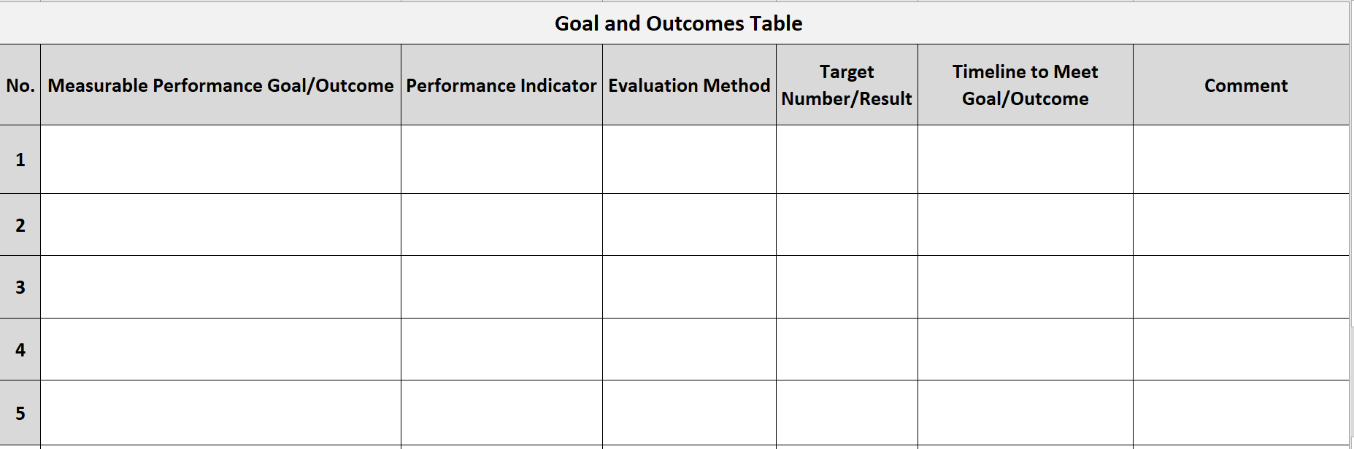

Appendix J: Timeline

