General Instructions for the Completion of a Budget Justification

The budget justification must include the following information:
  - Each line item on the Budget Form must be explained, and the cost provided for each. Each line item on the Budget Form pertains to projected costs.
  - The total for each line item on the Budget Justification must match the total for each line item on the Budget Form.
  - Administrative Costs cannot exceed 10 % of the requested funding.

- Staff Salaries – List all staff positions by title. State the annual salary of each person, the percentage of each person’s time devoted to the project, the amount of each person’s salary funded by the grant, and the total personnel cost for the period of performance. Be sure to breakout administrative and program salaries.

For example:

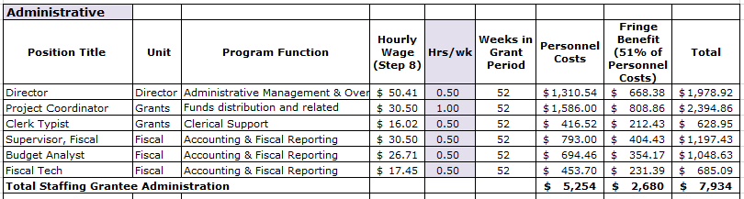

- Fringe Benefits – Provide the overall fringe benefit percentage which reflects the recipient’s organizational fringe, and list the components included, such as health insurance, FICA, retirement, etc. Provide the fringe benefit calculation for each staff position listed under the salary line item. Be sure to breakout administrative and program fringe.

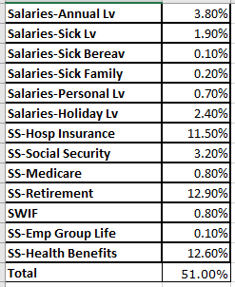

- Operational Expenses – List all anticipated direct operational expenses and corresponding amounts being supported by the grant here. List each item in sufficient detail for the grantor to determine whether the costs are reasonable or allowable (cellphone, rent, utilities, video conferencing services, printing, postage, supplies, staff travel, etc.).

Supplies – List each item in sufficient detail for the grantor to determine whether the costs are reasonable or allowable. Identify if the supply will remain with participants or if supplies are to remain with program provider for program use. List the quantity and unit cost per item. No one supply item is to exceed more than $5,000. Items with a unit cost of more than $5,000 are equipment.

Supplies can be purchased using the Micro Purchase Method. Procurement by micro-purchase is the acquisition of supplies or services in which the aggregate dollar amount does not exceed $3,000 (or $2,000 in the case of acquisitions for construction subject to the Davis-Bacon Act). To the extent practicable, the non-federal entity must distribute micro-purchases equitably among qualified suppliers. Micro-purchases may be awarded without soliciting competitive quotations if the non-federal entity considers the price to be reasonable.

- Other Program Expenses – List each item in sufficient detail for the grantor to determine whether the costs are reasonable or allowable. Costs included here should not fit into any other line-item category.

Note: If including equipment, be sure to identify each item of equipment to be purchased which has an estimated acquisition cost of $5,000 or more per unit and a useful lifetime of more than one year. List the quantity and unit cost per item. Items with a unit cost of less than $5,000 are supplies.

Equipment – List each item in sufficient detail for the grantor to determine whether the costs are reasonable or allowable.

Equipment can be purchased using the Small Purchase Method. All purchases between $3,000 and $150,000 can use the “small purchase procedures” as the procedures are “relatively simple and informal.” Price or rate quotations must be obtained from three qualified sources. Quotations can be obtained in writing, listed by contractor price on a website, or generated via an online search.

- Indirect Costs – If charging indirect costs to the grant, this line item must be populated. Include the current approved Negotiated Indirect Cost Rate Agreement, signed by the Federal cognizant agency, or a de minimis justification, as an attachment to the narrative. This should only be submitted with the grant application if outlined as an allowable expense and broken out between administration and program.

